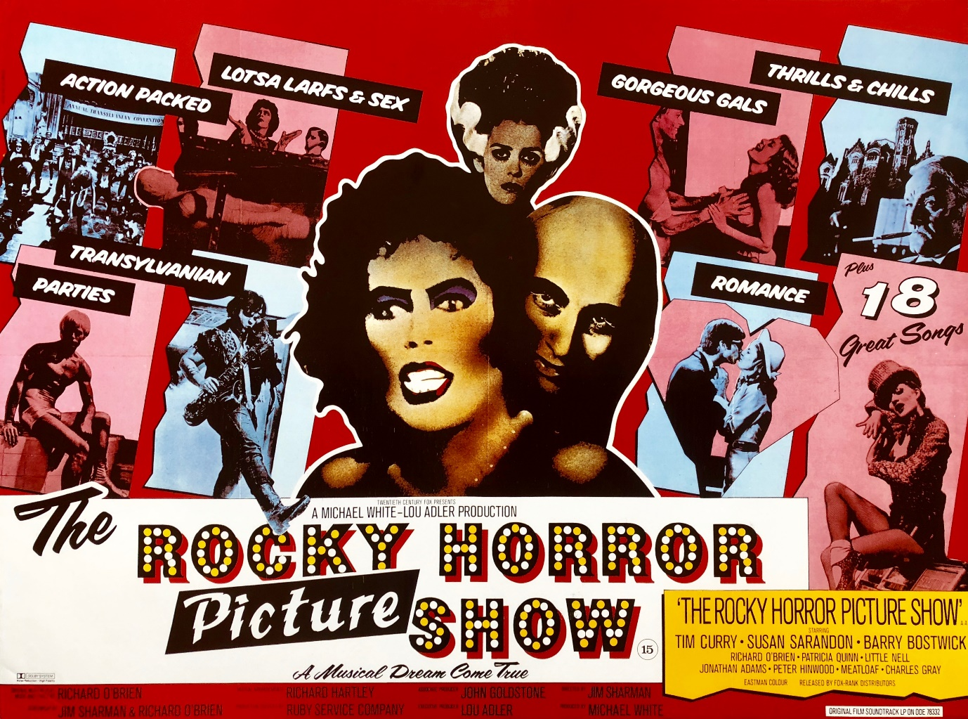

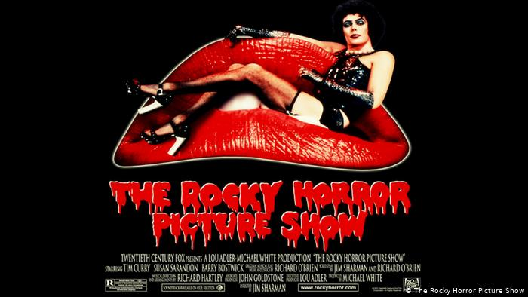

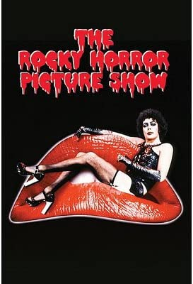

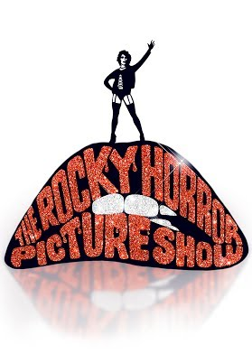

Richard O’Brien’s legendary rock n roll musical, with

The story centres on a young, engaged couple whose car breaks down in the rain near a castle where they seek a telephone to call for help. They meet the charismatic, mad transvestite scientist, Dr Frank n’Furter who unveils hie new creation, a sort of Frankenstein-style monster in the form of an artificially made, physically fit, blonde hair and tanned, “Rocky”.

Gates open at 7.00pm, film starts at 8.45pm.